



**JOINING REPORT**

Date of joining: 11th May 2022

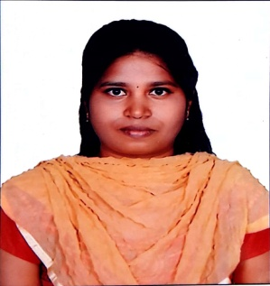

Dear Sir/Madam,

With reference to your offer of appointment I, Jayashree Ragavan _ do hereby join my duties as (***Designation***) Senior Software Test Engineer .

**I hereby undertake to abide by the rules, regulations, terms and conditions applicable to me in Tech Mahindra.**

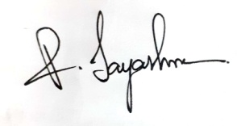

Authorized Signatory Signature of the associate

Name: Name: Jayashree Ragavan

Copyright © 2013, Tech Mahindra. All rights reserved. Version 2.3